

Foundations of Programming
Assignment No. : 5
PROBLEM STATEMENT:
Write a program in C to perform basic matrix operations such as:
1. Addition of two matrices
2. Saddle point of a matrix
3. Inverse of a matrix
4. Magic square of a matrix

OBJECTIVE:
• To understand matrix representation in C using two-dimensional arrays.
• To implement various matrix operations using C programming.
• To develop logical thinking for solving matrix-based problems.

THEORY:
Matrix operations are widely used in engineering and scientific applications. Addition of matrices involves adding corresponding elements. A saddle point is an element that is the minimum in its row and maximum in its column. The inverse of a matrix exists only for square matrices with non-zero determinant. A magic square is a square matrix in which the sums of elements in each row, column, and diagonals are equal. (ADD Example for 1. Addition of two matrices
2. Saddle point of a matrix
3. Inverse of a matrix
4. Magic square of a matrix
)

PLATFORM:
Linux

ALGORITHM:
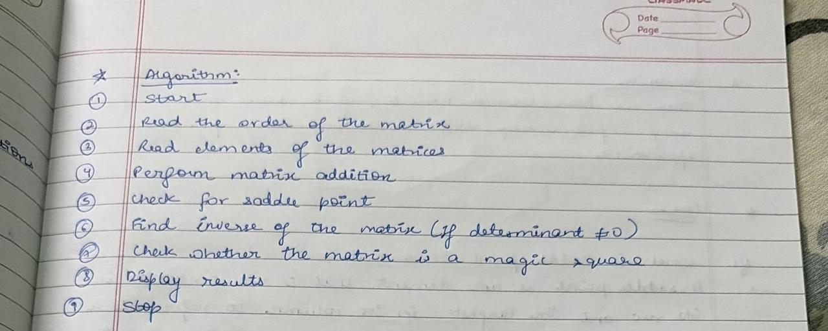

FLOWCHART:
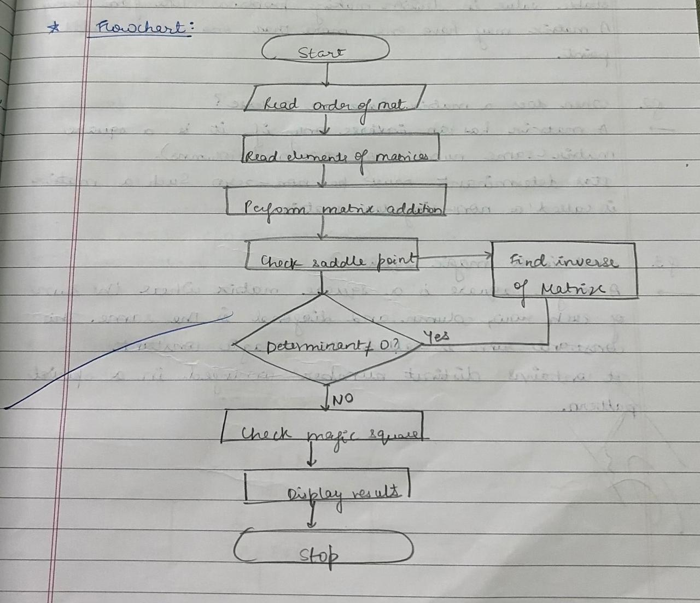

C PROGRAM: (Type C Program)
#include <stdio.h>

int main() {
int ch, i, j, n, r, c;

do {
printf("\n1.Addition 2.Saddle 3.Inverse(2x2) 4.Magic 5.Exit\n");
printf("Enter your choice: ");
scanf("%d", &ch);

switch(ch) {

case 1: { // Addition
int a[10][10], b[10][10];
printf("Enter rows and columns: ");
scanf("%d%d",&r,&c);

printf("Enter first matrix:\n");
for(i=0;i<r;i++)
for(j=0;j<c;j++)
scanf("%d",&a[i][j]);

printf("Enter second matrix:\n");
for(i=0;i<r;i++)
for(j=0;j<c;j++)
scanf("%d",&b[i][j]);

printf("Result:\n");
for(i=0;i<r;i++) {
for(j=0;j<c;j++)
printf("%d ", a[i][j]+b[i][j]);
printf("\n");
}
break;
}

case 2: { // Saddle Point
int a[10][10], min, col, k, f=0;
printf("Enter order of square matrix: ");
scanf("%d",&n);

printf("Enter matrix:\n");
for(i=0;i<n;i++)
for(j=0;j<n;j++)
scanf("%d",&a[i][j]);

for(i=0;i<n;i++) {
min=a[i][0]; col=0;
for(j=1;j<n;j++)
if(a[i][j]<min){min=a[i][j]; col=j;}

for(k=0;k<n;k++)
if(a[k][col]>min) break;

if(k==n){ printf("Saddle Point = %d\n",min); f=1; }
}
if(!f) printf("No Saddle Point\n");
break;
}

case 3: { // Inverse 2x2
float a[2][2], d;
printf("Enter 2x2 matrix:\n");
for(i=0;i<2;i++)
for(j=0;j<2;j++)
scanf("%f",&a[i][j]);

d=a[0][0]*a[1][1]-a[0][1]*a[1][0];
if(d==0) printf("Inverse not possible\n");
else {
printf("Inverse matrix:\n");
printf("%.2f %.2f\n", a[1][1]/d, -a[0][1]/d);
printf("%.2f %.2f\n", -a[1][0]/d, a[0][0]/d);
}
break;
}

case 4: { // Magic Square
int a[10][10], sum=0, t, flag=1;
printf("Enter order of square matrix: ");
scanf("%d",&n);

printf("Enter matrix:\n");
for(i=0;i<n;i++)
for(j=0;j<n;j++)
scanf("%d",&a[i][j]);

for(j=0;j<n;j++) sum+=a[0][j];

for(i=1;i<n;i++) {
t=0;
for(j=0;j<n;j++) t+=a[i][j];
if(t!=sum) flag=0;
}

for(j=0;j<n;j++) {
t=0;
for(i=0;i<n;i++) t+=a[i][j];
if(t!=sum) flag=0;
}

t=0;
for(i=0;i<n;i++) t+=a[i][i];
if(t!=sum) flag=0;

t=0;
for(i=0;i<n;i++) t+=a[i][n-i-1];
if(t!=sum) flag=0;

if(flag) printf("It is a Magic Square\n");
else printf("Not a Magic Square\n");
break;
}

case 5:
printf("Exiting...\n");
break;

default:
printf("Invalid choice!\n");
}

} while(ch!=5);

return 0;
}
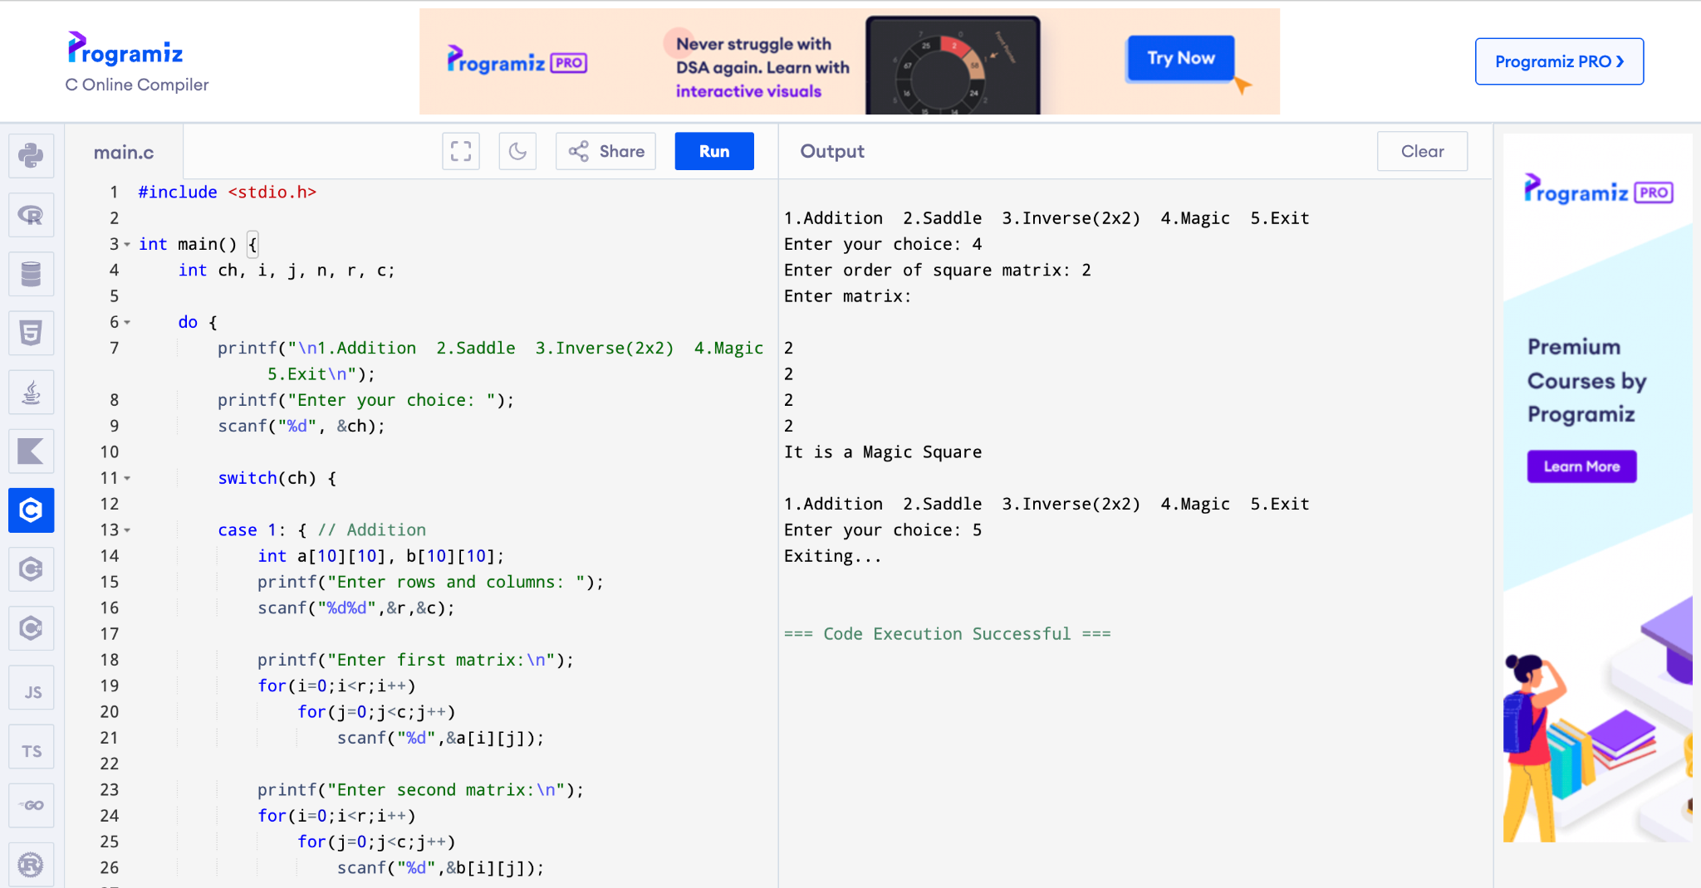

CONCLUSION:
Thus, we have learned how to perform basic matrix operations using C programming and understood their practical applications.

FAQs:
1. What is a saddle point in a matrix?
2. When does a matrix have an inverse?
3. What is a magic square?

